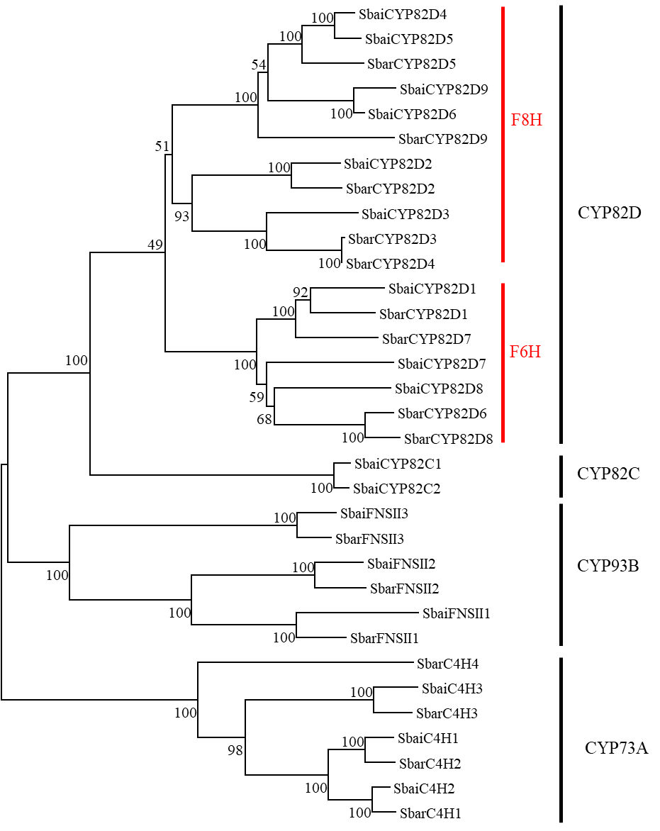

Supplementary Figure S18. The phylogenetic analysis of CYP82D, CYP93B, and CYP73A members from *S. baicalensis* and *S. barbata* using the maximum likelihood method.